Claremont bank surgery
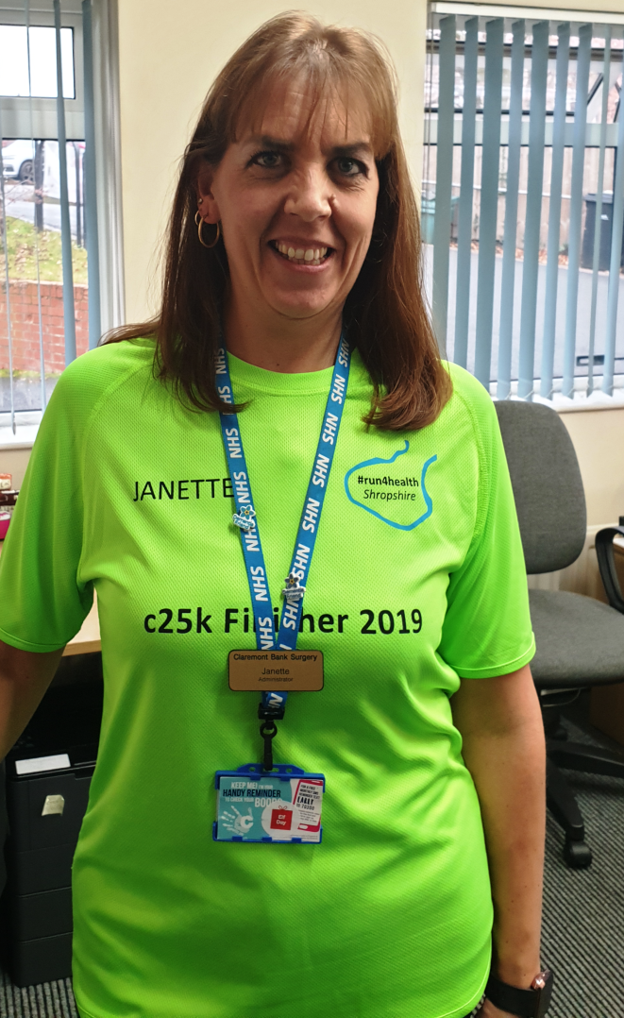
December 2019 newsletter
COUCH TO 5K
On the 23rd of November Janette Holloway, a member of our administration team, ran the 5k park run for our surgery. Janette attended a couch to 5k running club for 10 weeks before doing the park run in Shrewsbury Quarry. The couch to 5k is an excellent way for you to start running for beginners. You can download the NHS Couch to 5k app to get started. If you would like to join in with the park run you can participate for free at Shrewsbury Quarry. Start at the band stand at 9am.

Claremont Bank Surgery Christmas Hours
Claremont Bank Surgery will be closed on the following days over Christmas.
- Wednesday 25th December
- Thursday 26th December
- Wednesday 1st January
You can still contact 111 for non-urgent medical advice and the urgent care centre at The Royal Shrewsbury Hospital is open every day 8am-8pm.

[Book GP appointments and order prescriptions online
All GP practices now offer online services to:
- book or cancel appointments
- order repeat prescriptions
- see parts of your medical record
Every month, over 1 million appointments are booked online and over 2 million prescriptions are ordered without needing to visit a GP.
Ask for form at reception.

eConsult
On the 7th January 2020 Claremont Bank Surgery will start to use eConsult as another way for you get in contact with the surgery. eConsult is free to use for NHS patients. Use eConsult to ask your GP surgery about your health symptoms, conditions or treatments. You can even request things like sick notes and GP letters.
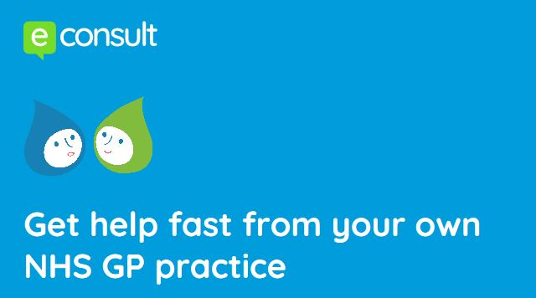

DO YOU CARE?
Who is a carer?
A carer is someone of any age who cares, unpaid for a family member or friend who, due to illness, disability, mental health problems, addiction, cannot cope without support.
Community Care Coordinator
Becky Kelly is our community care coordinator. Becky works alongside our team of administrative and clinical staff in order to offer patients additional support in areas like caring for someone, living with long term conditions, mobility difficulties, loneliness and bereavement.

If you feel you may benefit from the support Becky could provide, please contact the surgery on 01743 248244.

DO YOU CAre?
Who is a young carer?
A young carer is someone under 18 who helps look after someone in their family, or a friend, who is ill, disabled, has mental health issues or misuses drugs or alcohol.
What might a young carer do?
- Practical tasks, such as cooking, housework, shopping and family budgeting
- Emotional support, such as talking to someone who is stressed
- Personal care, such as helping someone out of bed with a hoist and to help them to dress
- Helping siblings
- Helping to give medicine, collecting prescriptions
Carers Emergency Response Service
Shropshire Carers Service also provides a Carers Emergency Response Service (CERS). In the event of an unforeseen emergency where you are unable to care for your loved one, CERS could be the lifeline you need. Our experienced Carer Support Workers will give you peace of mind, ensuring your loved one is well looked after by providing high quality support at a time that could be very stressful for you as a carer.
There is no charge for this service for the first 48 hours (72 over a weekend or bank holiday). During this time plans will be made to organise on-going care if needed.
To enquire call 01743 341995 or email Shropshire@carerstrust4all.org.uk

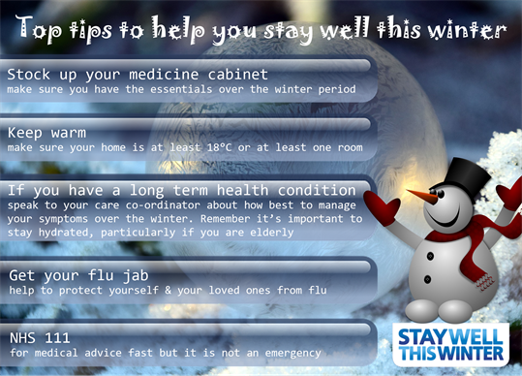

Look in on vulnerable neighbors and relatives
Check on older neighbors and relatives, and those with heart or breathing (respiratory) problems, to make sure they:
- are safe and well
- are warm enough, especially at night
- have stocks of food and medicines so they do not need to go out during very cold weather
If you're worried about a relative or elderly neighbor, contact your Shropshire council or call the Age UK helpline on 0800 678 1602 (8am to 7pm every day).

Who is most at risk from the cold?
Some people are more vulnerable to the effects of cold weather. This includes:
- people aged 65 and older
- babies and children under the age of 5
- people on a low income (so cannot afford heating)
- people who have a long-term health condition
- disabled people
- pregnant women
- people who have a mental health condition

Keep your home warm
Follow these tips to keep you and your family warm and well at home:
- if you're not very mobile, are 65 or over, or have a health condition, such as heart or lung disease, heat your home to at least 18C
- keep your bedroom at 18C all night if you can – and keep the bedroom window closed
- if you're under 65, healthy and active, you can safely have your home cooler than 18C, as long as you're comfortable
- use a hot water bottle or electric blanket to keep warm in bed – but do not use both at the same time
- have at least 1 hot meal a day – eating regularly helps keep you warm
- have hot drinks regularly
- to reduce the risk of sudden infant death syndrome (SIDS), babies should sleep in rooms heated to between 16C and 20C
- draw curtains at dusk and keep doors closed to block out draughts
- get your heating system checked regularly by a qualified professional

Help with heating costs
You may be able to claim financial and practical help with heating your home. Grants available include the Winter Fuel Payment and the Cold Weather Payment.
For more information on how to reduce your bills and make your home more energy efficient, go to the government's Simple Energy Advice website. Or call the Simple Energy Advice helpline on 0800 444 202.
You can also find advice in the section on financial help to heat your home in the Keep Warm, Keep Well leaflet.
It's worth claiming all the benefits you're entitled to as soon as winter begins

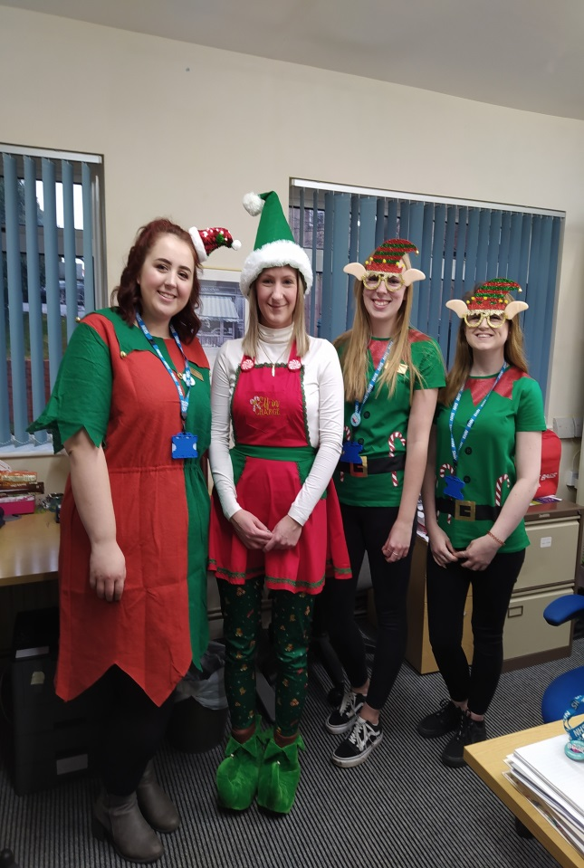
On the 6th December the staff at Claremont Bank participated in elf day. We dressed up as elves to raise money and awareness about Alzheimer’s. Every donation raised for the Alzheimer’s Society makes sure people affected by Dementia are supported. Thousands of people depend on the society to live well and keep fighting. Here are some examples of what a donation could buy.
- £2 could pay for a DNA duplicator, used to understand the genetics of dementia.
- £50 could pay for 5 people to have 5 hours of support from the helpline.
- £150 could pay for two people with dementia to attend singing for the Bain sessions.
If you would like to make a donation visit www.alzheimers.org.uk/elfday

Elf Day!!

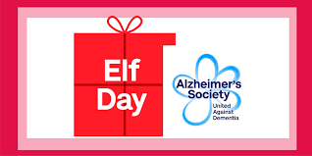

Merry Christmas from all the staff at Claremont Bank Surgery
And a healthy new year!!!

